**What is redux in react js ?**

React redux is a state management libraries used in react js.

React redux is allow components to read data from a redux.

It is used to store and dispatch actions to the store to update data from state.

Redux helps apps to scale by providing a sensible way to manage state through a unidirection data flow model.

**Advantage of Redux :**

Redux provides a dispatcher concepts or performing actions.

Redux has an only stored method to performing actions via reducer.

Redux used state management to updating data | view data | modify in data

Redux is official UI binding for react applications.

Its is kept upto- date with API changes to ensure that react components behave as expected.

Its is encouarge for good **'React architecture'**

It implements many performace to optimizations internally , which is allow to components re-render only when it acually needed.

**Redux life cycle architetcures**

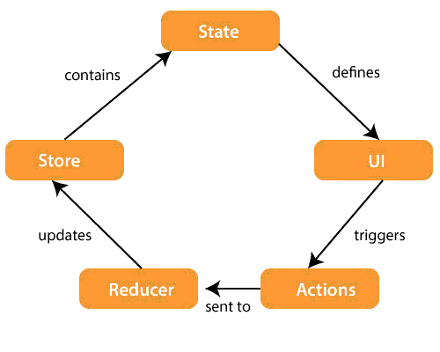

**Stores :** A store is a place where the entire state of your applications are listed. it is manages the status of the applications and dispatch(action) to the function.

It is a like a brain that is used to resposible for all moving parts in redux.

**Actions:** Action is sent or dispatched from the view whuch is payloads that can be read reducers.

It is pure object created to stores the informations of the users events.

It is includes informations such as type of action, time of occurence, location of occurence

It is cooridantes with states and its aims to change somthing in states.

**Reducer:** Reducer just like a pure function to return a new state from the inital state.

Reducer read the paylaods from the actions and then updates the stores cia state accosridngly

**How to install React redux Dev tools and add extension in broswers:**

**just go on google and add redux dev tools**

just add extentions in chrome broswers

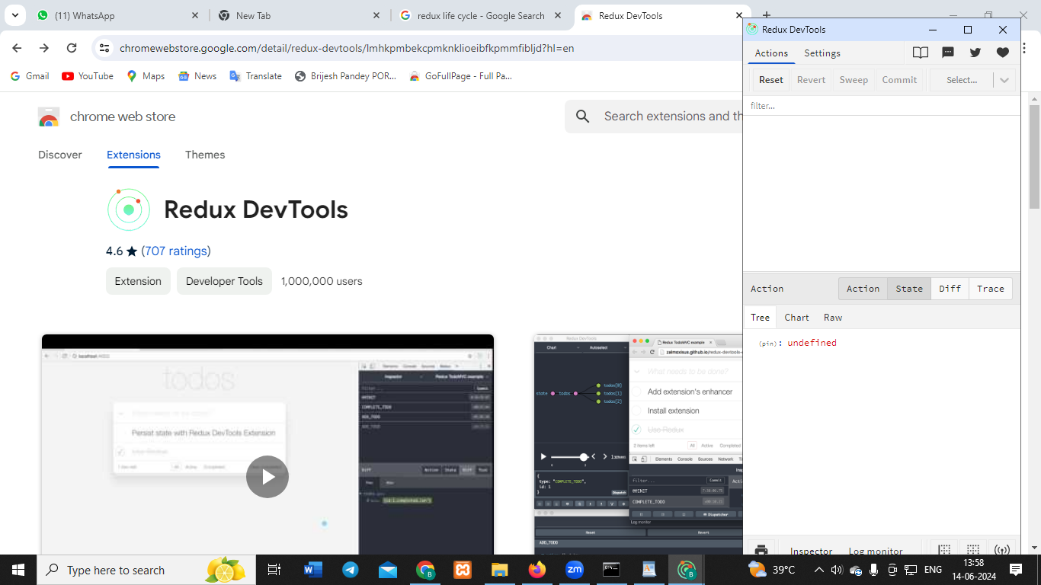

**How to install redux in react app :**

steps 1: npm create vite@latest

step 2:create project name

step3:select language

step4: select javascript

step5: cd appname

step6:npm install

step7:npm install redux react-redux --save

step8: npm install redux

step8: npm install react-bootstrap bootstrap

step9: npm run dev

**Create some folders inside of src**

src=>actions

src=>components

src=>container

Src=>reducer